POLAR BEARS
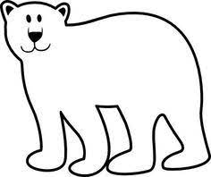
Polar bears live in the Artic. They have a white fur coat and thick fat called blubber to keep them warm in the cold. Polar bears like to eat seals. They will also eat walruses, small mammals, birds, fish and some plants.
Female polar bears have babies in winter and usually have two cubs. The cubs stay with their mother for 2 years to learn how to survive in the Artic.
Polar bears live in:
Australia* Antarctica*the Artic*Africa
What keeps a polar bear warm?
An igloo*a fire*blubber and fur coat*swimming in water
How long do cubs stay with their mother?
4 years*7 years*2 months*2 years
What do polar bears like to eat?
Fruit*seals*ice*vegetables

POLAR BEARS
Polar bears live in the Artic. They have a white fur coat and thick fat called blubber to keep them warm in the cold. Polar bears like to eat seals. They will also eat walruses, small mammals, birds, fish and some plants.
Female polar bears have babies in winter and usually have two cubs. The cubs stay with their mother for 2 years to learn how to survive in the Artic.
Polar bears live in:
Australia* Antarctica*the Artic*Africa
What keeps a polar bear warm?
An igloo*a fire*blubber and fur coat*swimming in water
How long do cubs stay with their mother?
4 years*7 years*2 months*2 years
What do polar bears like to eat?
Fruit*seals*ice*vegetables
What keeps a polar bear warm?
An igloo*a fire*blubber and fur coat*swimming in water

How long do cubs stay with their mother?
4 years*7 years*2 months*2 years

What do polar bears like to eat?
Fruit*seals*ice*vegetables

