REVISION – 5TH CLASS
NAME: ……………………………………………………
My body
Czech | English
žaludek
paže
vlasy
záda
koleno
pusa
hlava

What is wrong?
wardrobe | desk | armchair | sink
pill | lamp | fridge | door

read | stretch | take | stay
about | turn | put in | shake

headache | must | earache | allergic
cold | fever | hurt | backache

X-ray | T- shirt | skirt | jeans
cap | dress | sweater | socks

quarter | half | o´clock | past
famous | time | hour | to

salt | rice | butter | bread
pie | thumb | coffee | tea

Plurals
one tooth – 2 …………………..
one person – 3 ………………….
a man – 5 ………………………….
a woman – 6 …………………….
one child – 9 ……………………
one foot – 2 …………………….
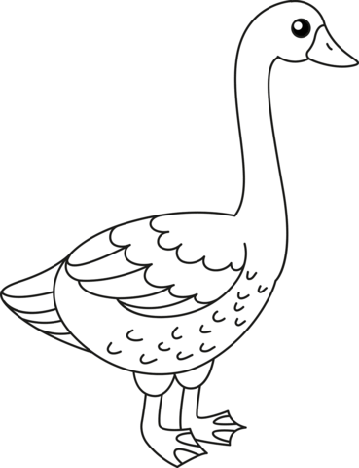
One ………………… 6 geese

Translate:
Potřebuje kapesník. (ona)
………………………………………………………………..
Musím chodit do školy.
……………………………………………………………….
V autě je chlapec. (There is…….)
……………………………………………………………….
Snídám v 7 hodin.
……………………………………………………………….
Nejsem v kině, protože je zavřeno.
………………………………………………………………
Why don´t you put on a sweater?
………………………………………………………………..
Rád (a) bych jednu kolu.
…………………………………………………………….
